I Can Win

1. Install Jenkins
2. Create a task which will perform the following:

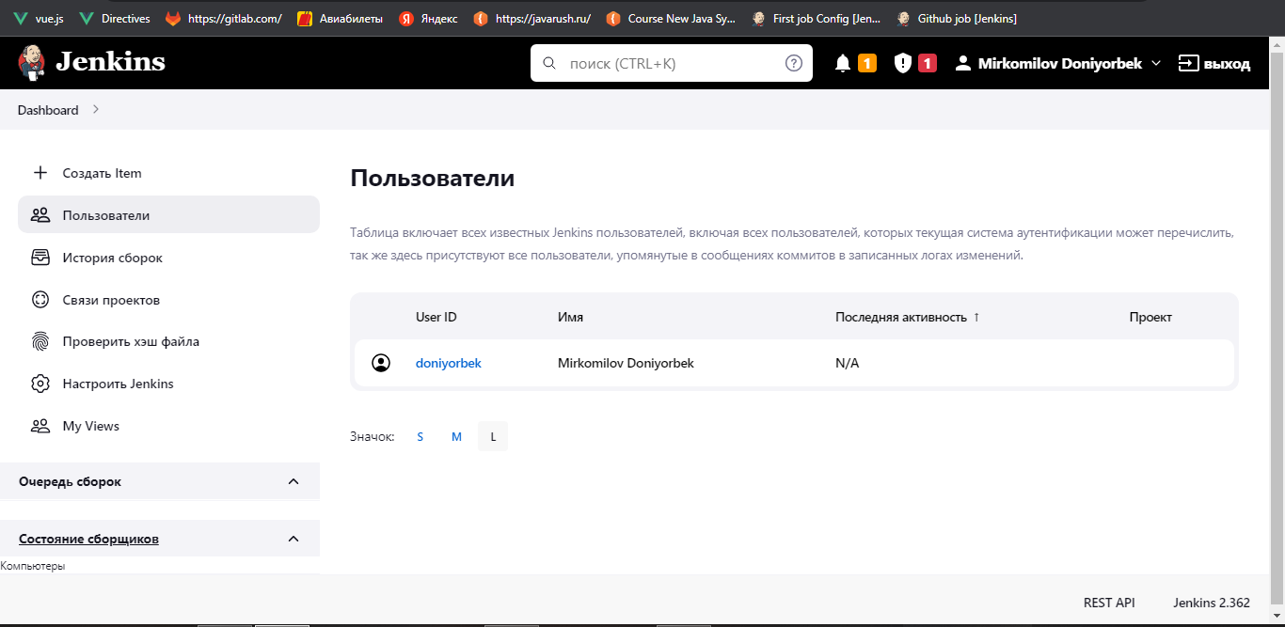 \* Clone the project

Launch tests from the project in Java directory with the help of mvn test goal

